Exercise 1: Setting Up JUnit

**Step 1:- Created a new java project named Exercise_1**

**Step 2:- Added JUnit dependency to the project**

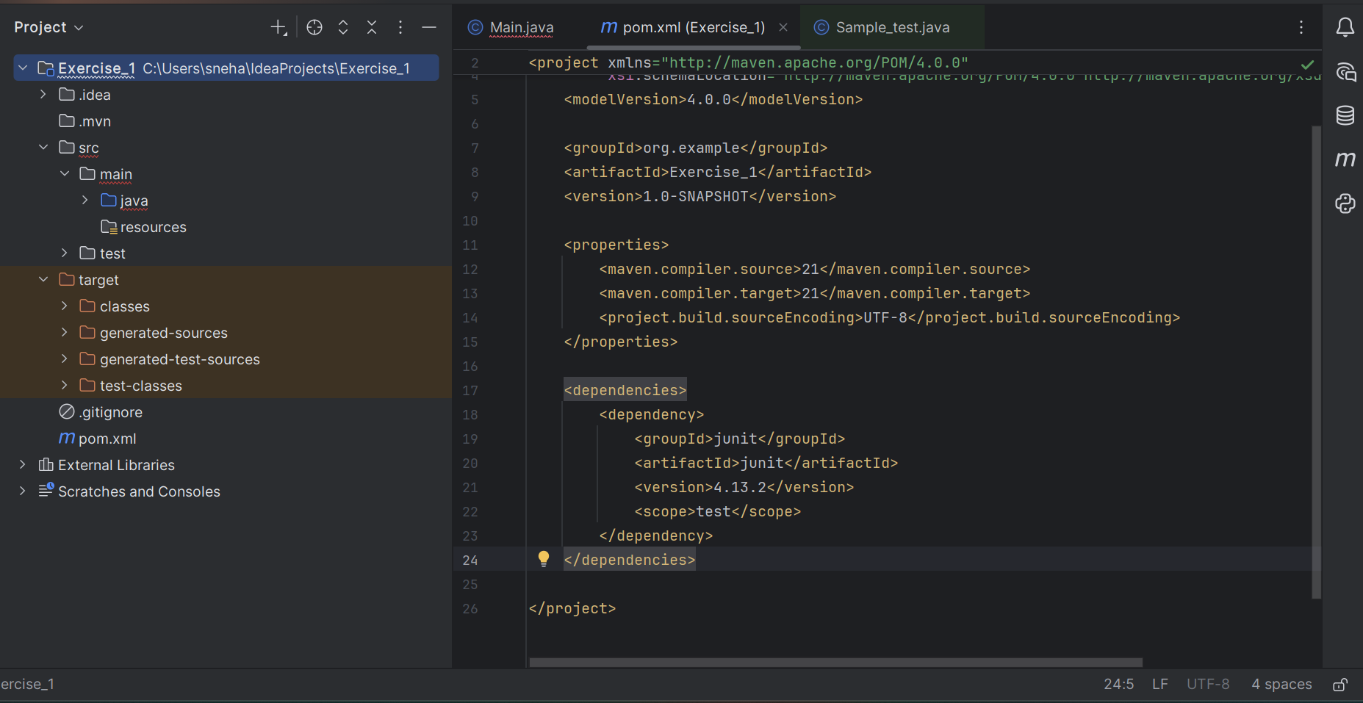

**Step-3:- Created a new test class for the project**

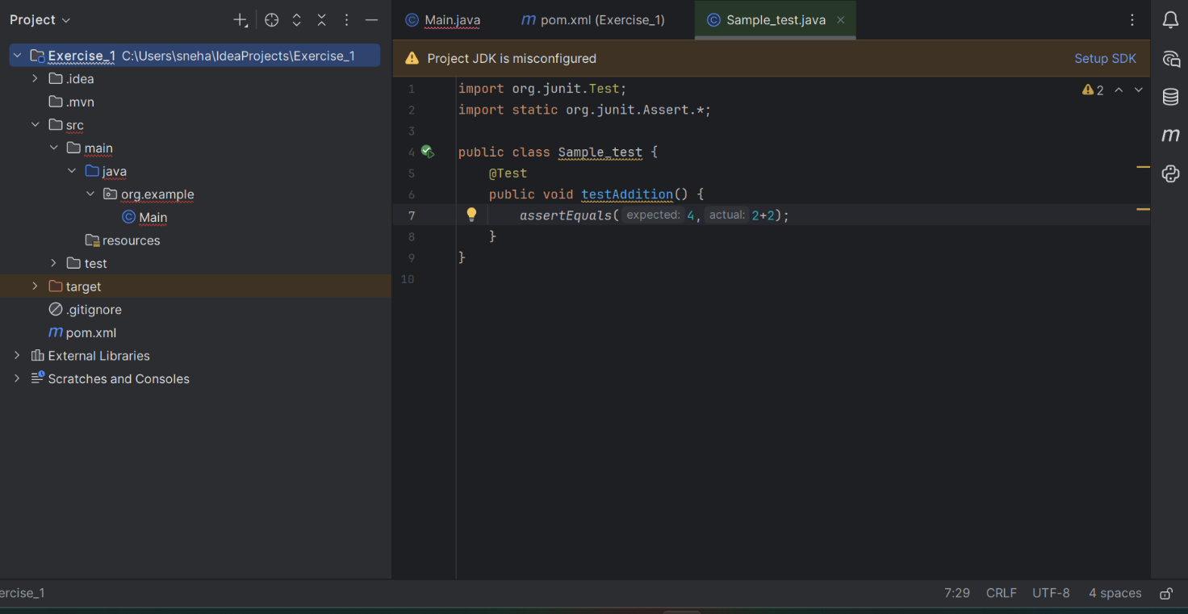

**Output:**

